# Lab manual 14!

# File Handling

# 

# Task 1:

# Write a C++ Program that will enter 5 integers from the user and write those in the file. After that

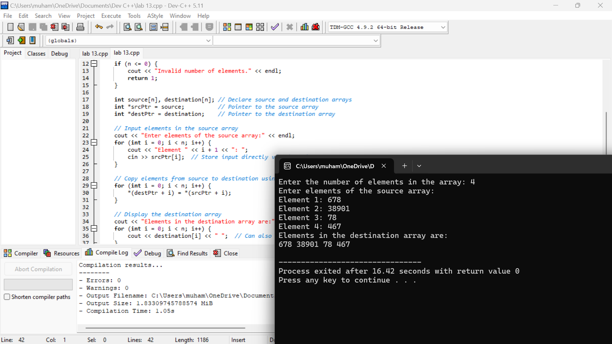

# 

***Theend!***